
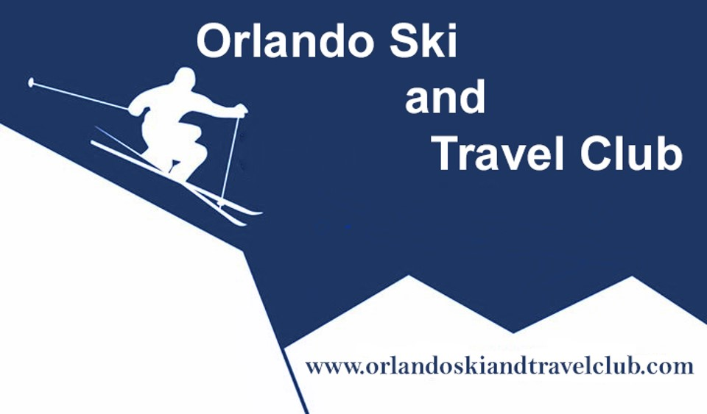

TRIP LEADER: Steve Clark 407-803-2239 EMAIL: SClark2575@cfl.rr.com

New Zealand/ Australia

November 3-18, 2018

The New Zealand experience is about discovering one of the best places on this planet – Queenstown NZ! Enjoy the majesty of towering mountains and Volcanoes while being able to stay on the edge of the Lake that the City surrounds. Pre-trip stayover in Hollywood, CA, 3 nights stay in Sydney Australia, stay in Auckland, NZ (Island of Winery’s, port bistros, museum) for 2 nights, Rotorua, NZ for 2 nights (Hobbiton, Mauri Indian experience, Red Wood tree canopy walk, museum), Queenstown, NZ for 5 nights. Queenstown - Main Street is lined with galleries, boutiques, restaurants, bistros, and nightlife. A wonderful City Park lines the lake with the most beautiful flowers and trees. Just a few of the optional adventure activities available are winery tours, zip lining, lugeing, speed boats on the river, True 4x4 Land Rover excursions through rivers and mountains. A definite “Bucket List” adventure!
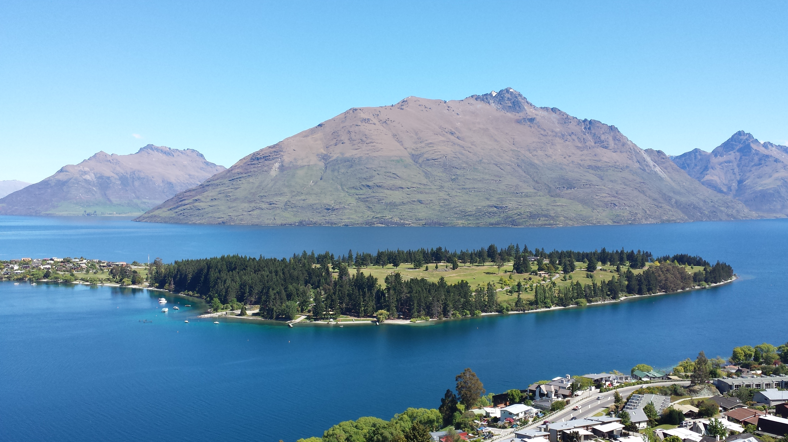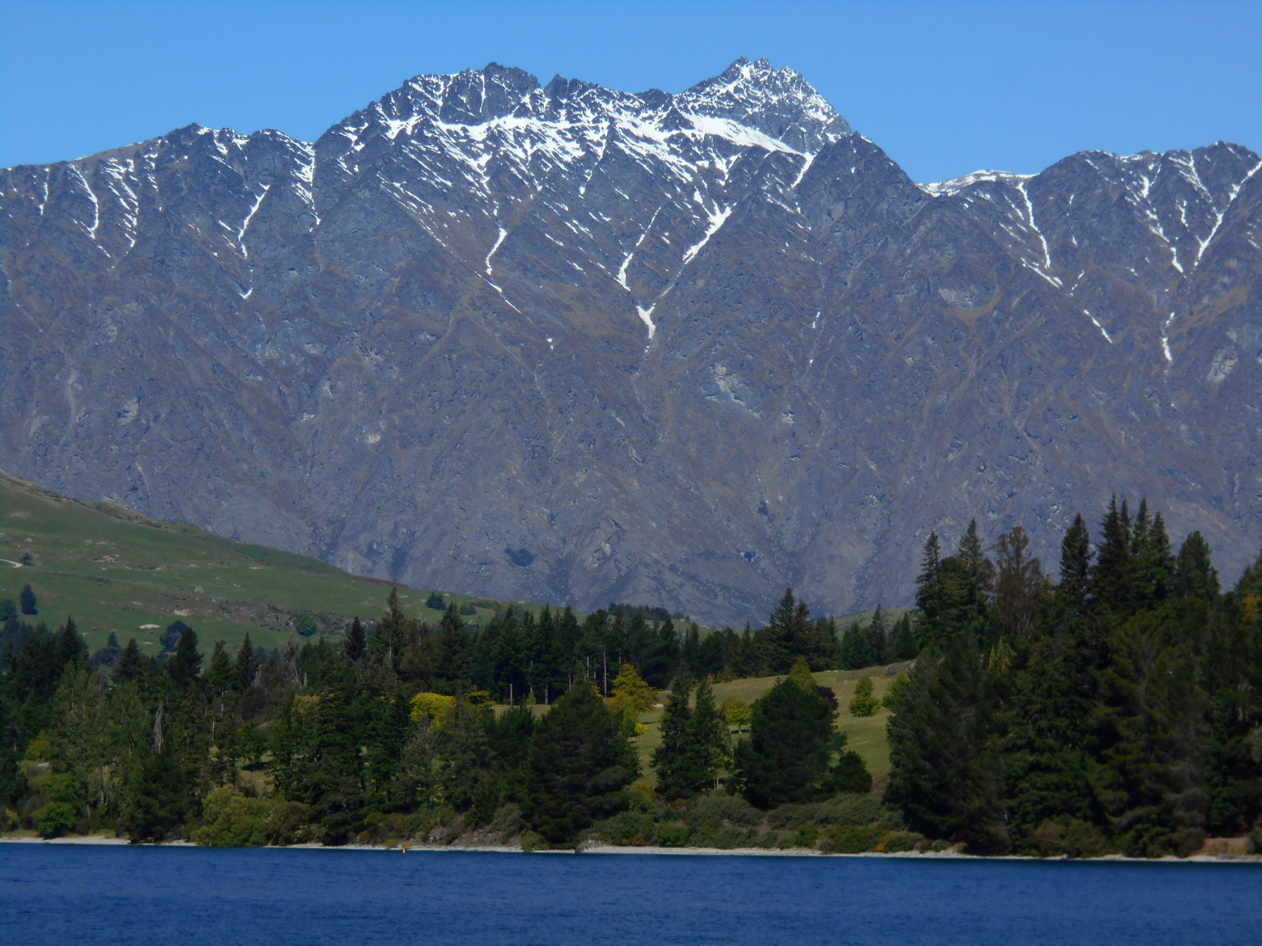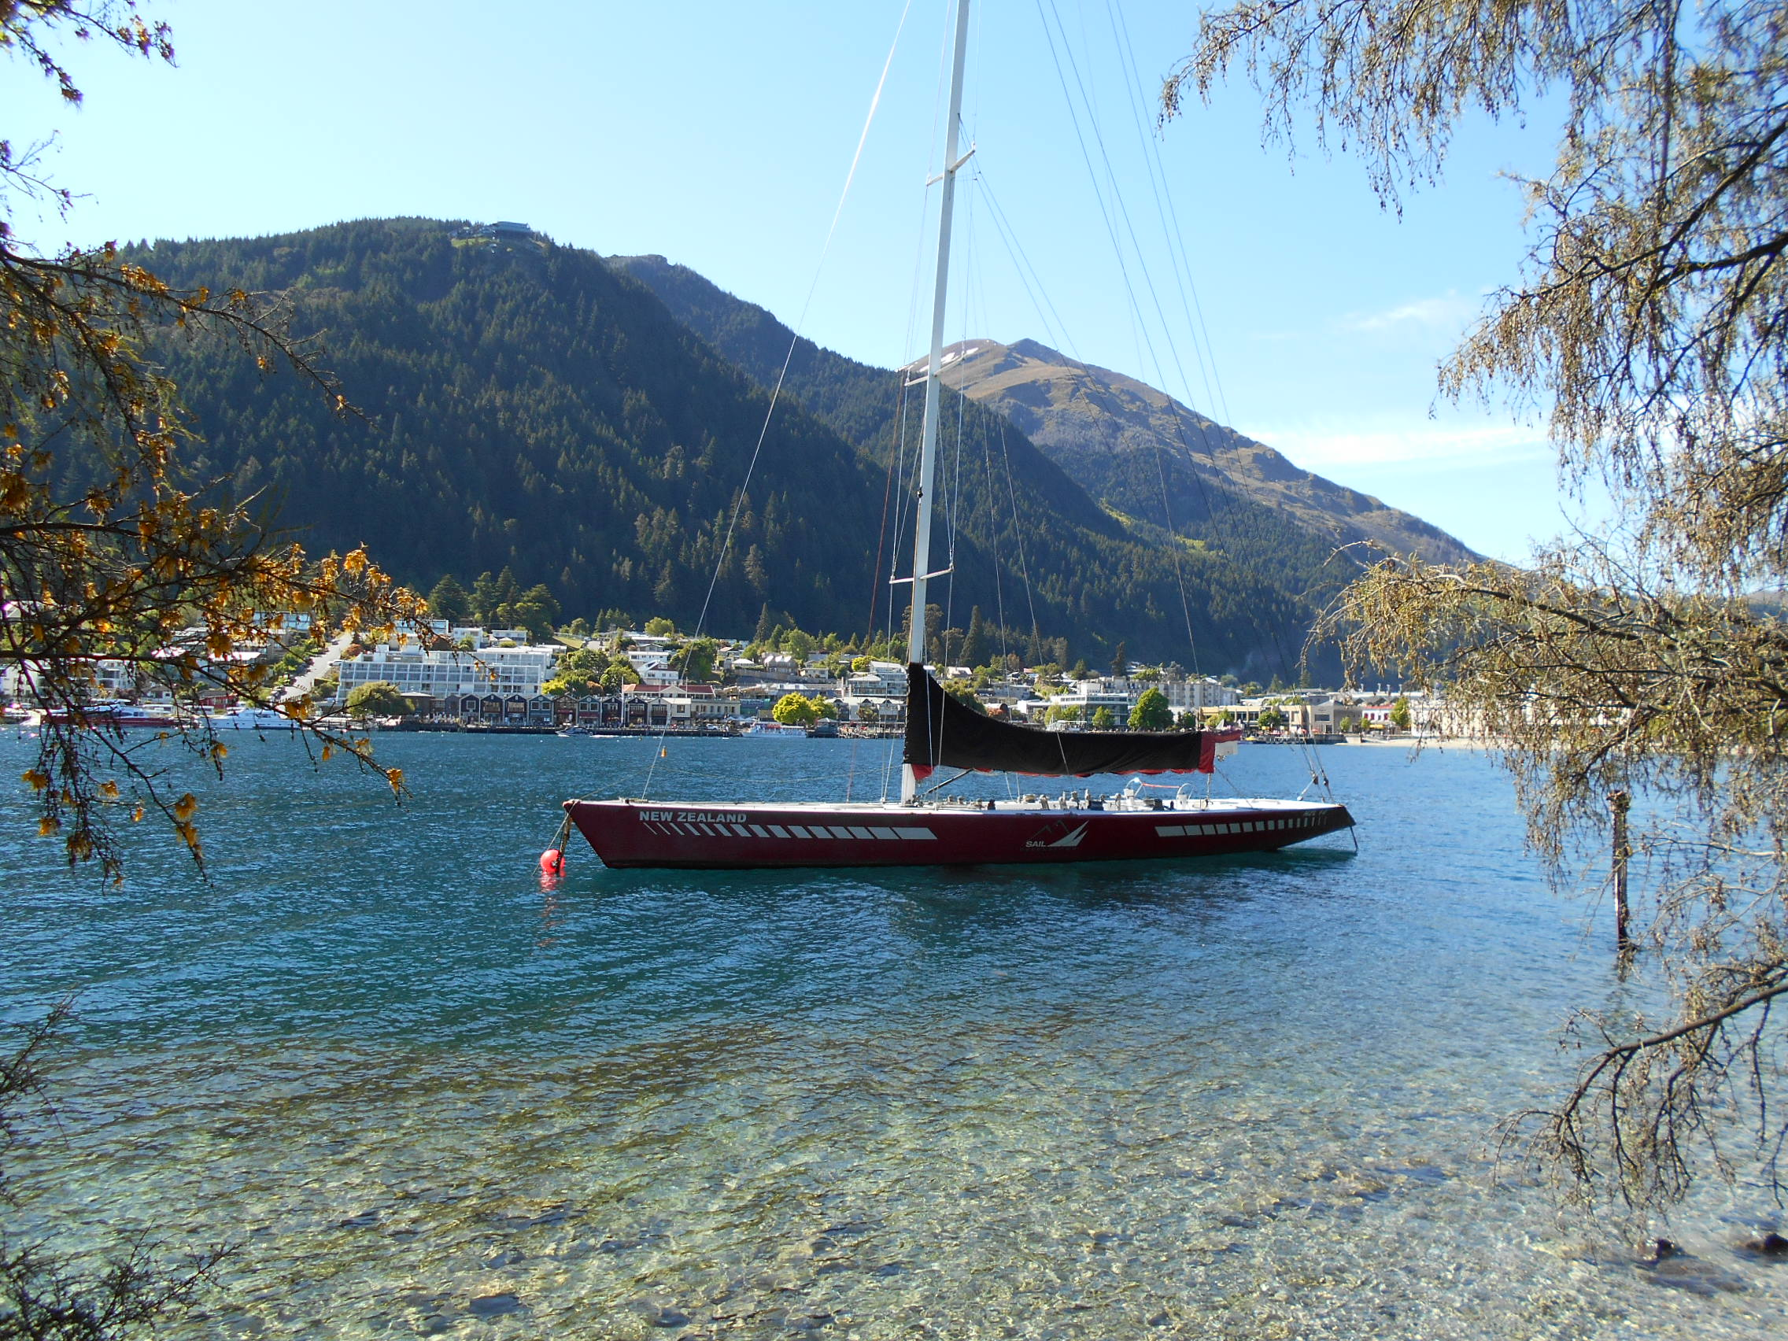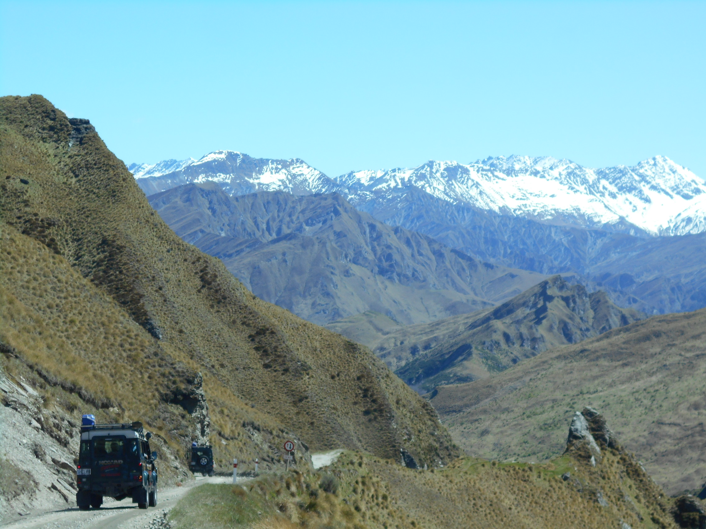
PRICE INCLUDES: Includes pre-trip stay over in Hollywood CA and post NZ 3 nights in Sydney, Australia! RT air into Auckland, in country flights, ground transfers in private motor coach, 3 nights in Sydney Australia, 2 nights in Auckland, 2 nights in Rotorua, and 5 nights in the heart of Queenstown NZ known as adventure capital of the world. Includes Hot bkfast daily; plus cruise to Waiheke Island of Wineries with Lunch and tastings, Lord of the Rings Hobbiton Village Tour, Maori Village Dinner experience, Skyline Gondola FSC Welcome Dinner, and SS Earnslaw Lake Cruise Dinner at Walter Peak Colonel’s Estate with sheep shearing show.
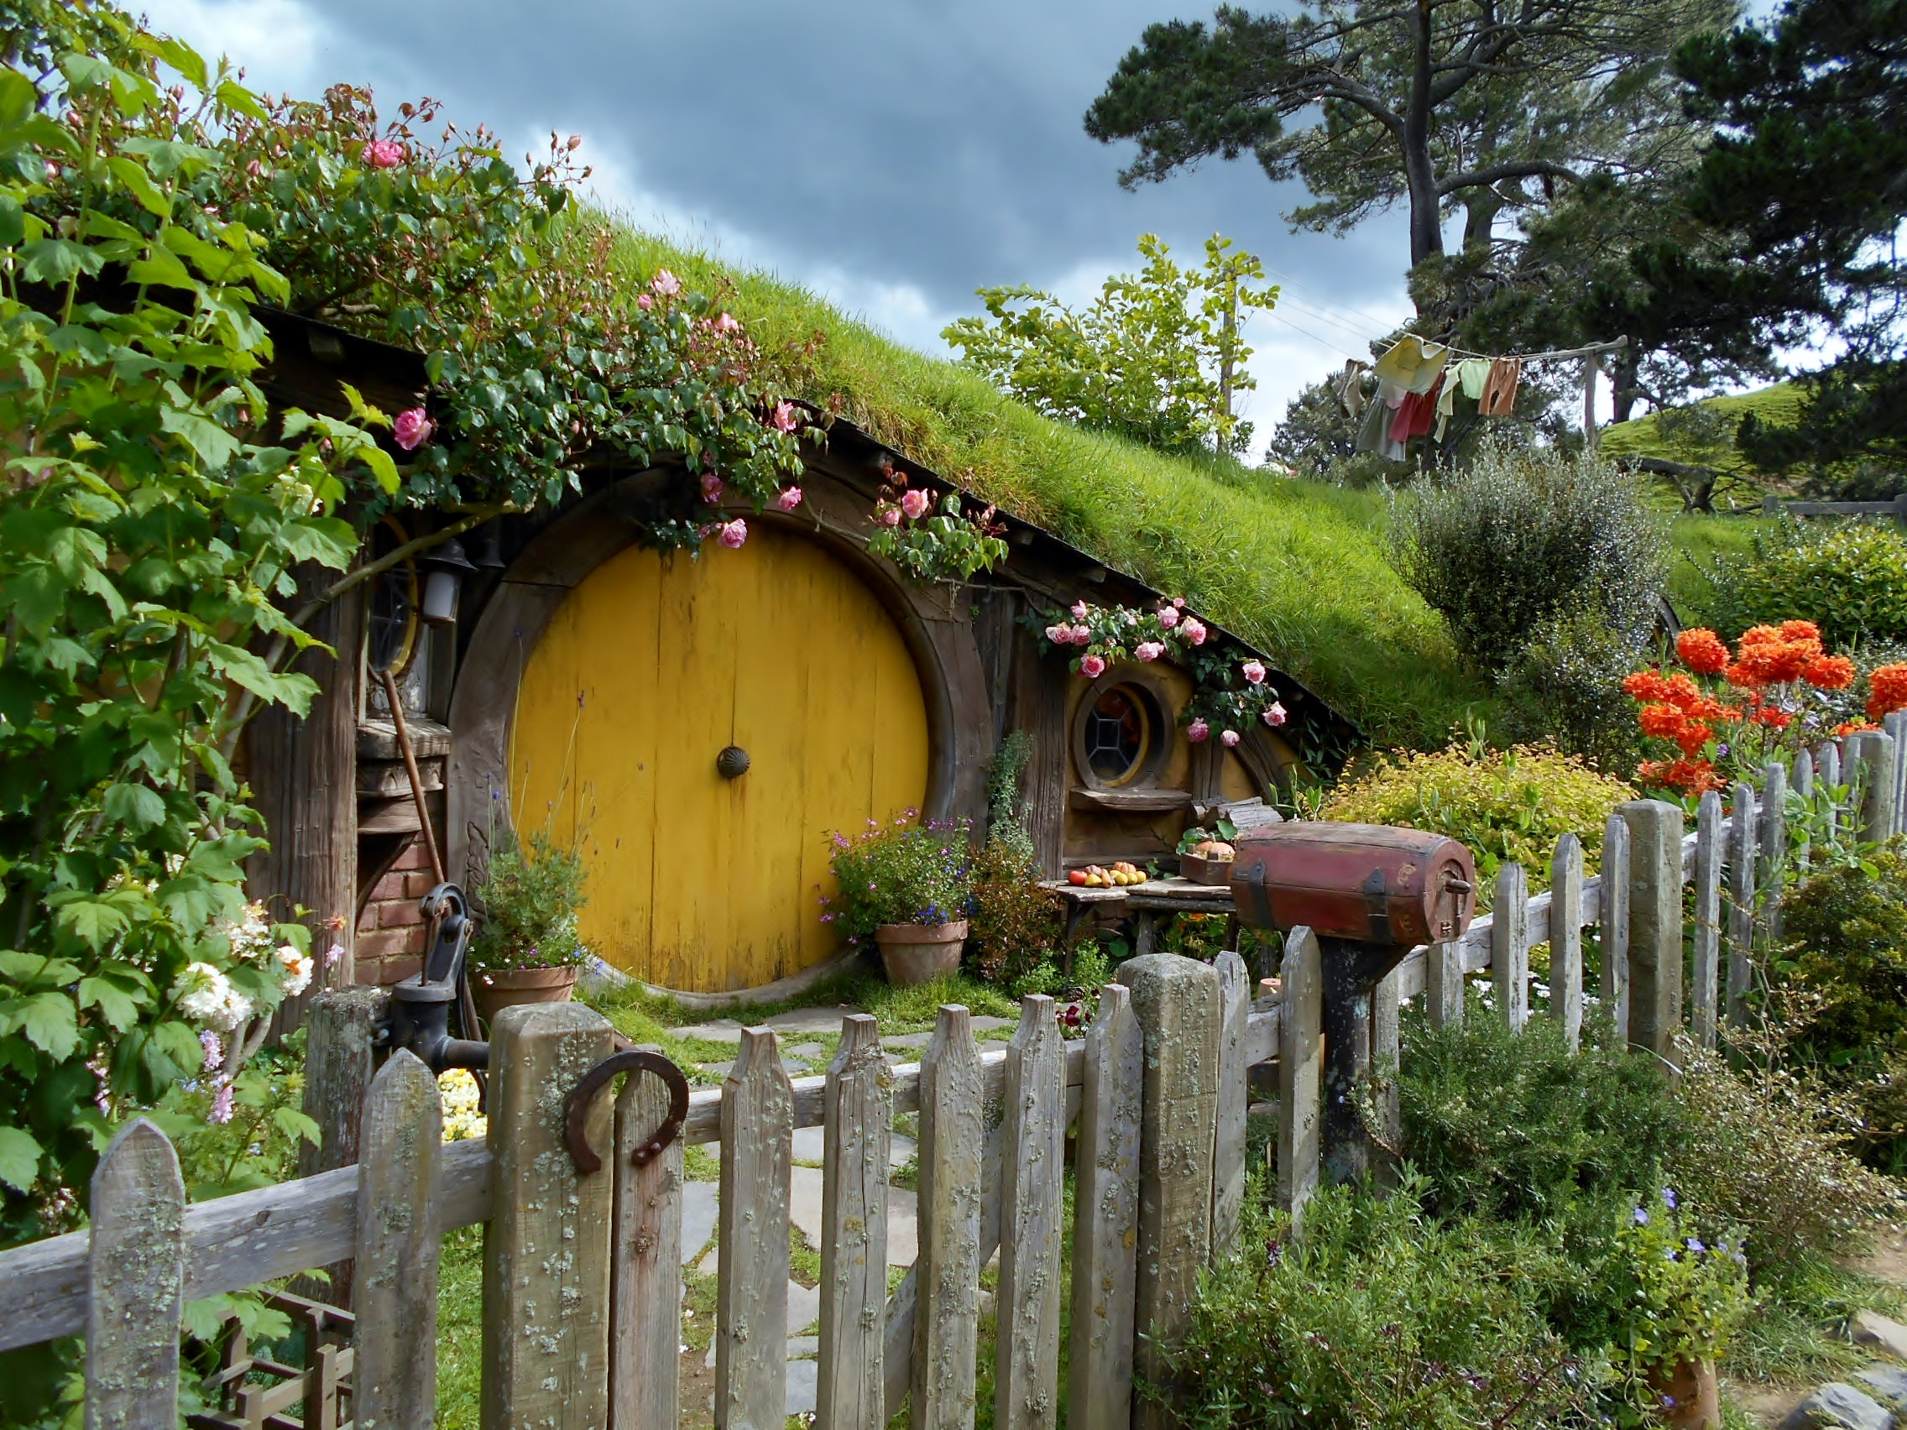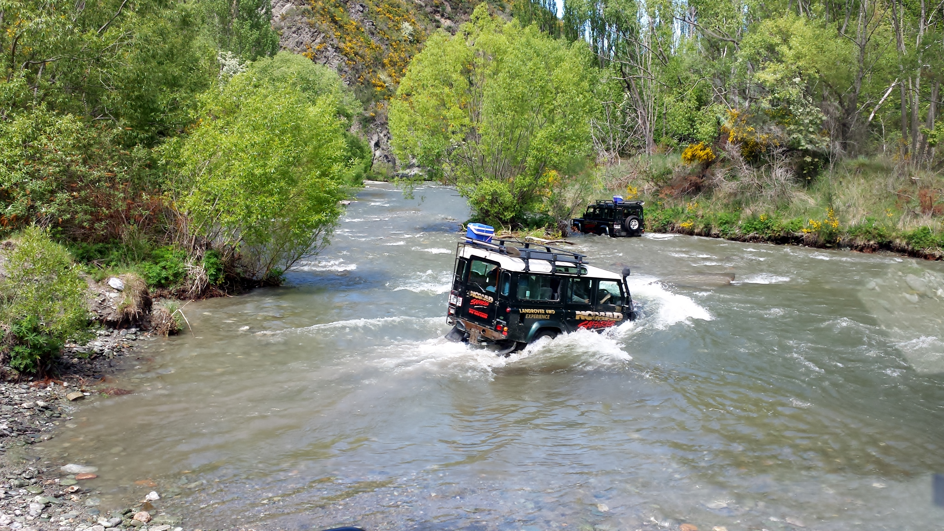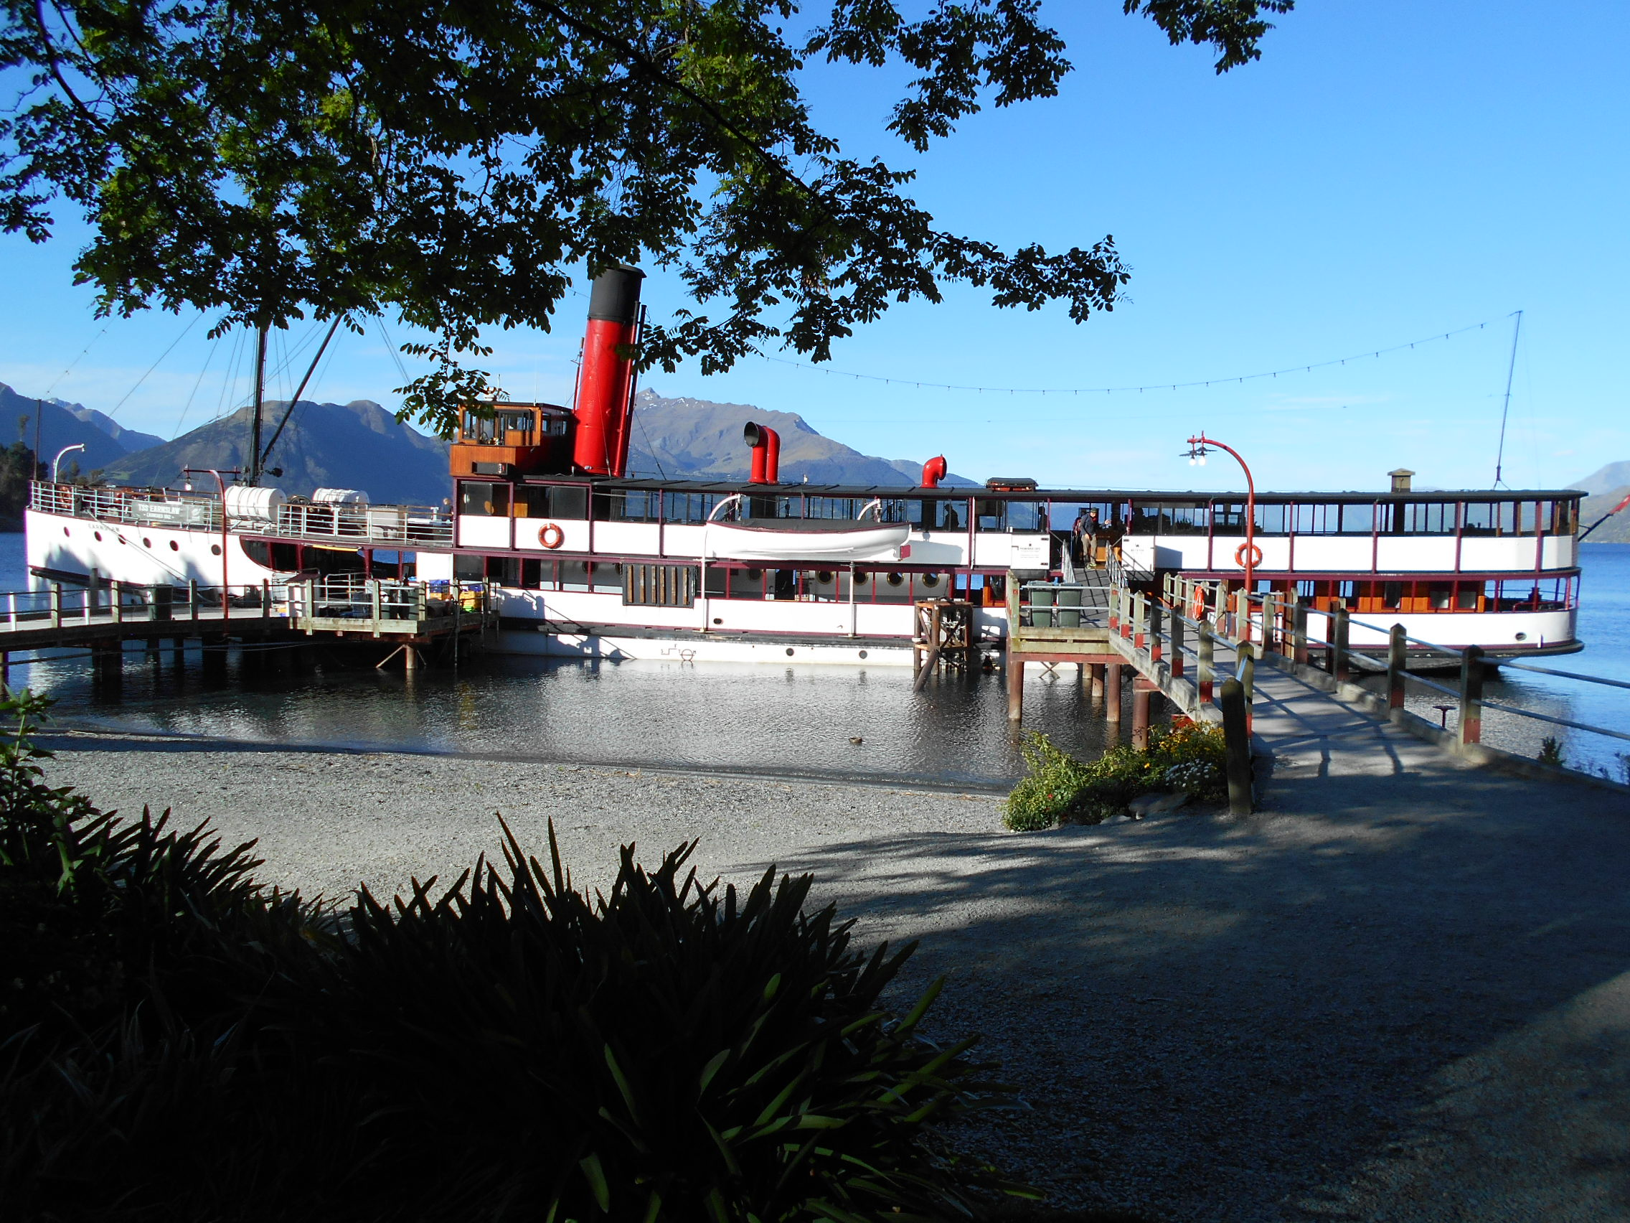

LODGING: 1 Night near LA Airport;
2 nights Cordis Hotel in Auckland http://www.cordishotels.com/en/auckland/
5 nights Novotel in Queenstown www.novotel.com/gb/hotel-5308-novotel-queenstown-lakeside/index.shtml
3 nights Sydney Austrailia www.hiltonsydney.com.au

AIR: RT from Orlando to Los Angeles
Air New Zealand - RT to Auckland, NZ (direct from Los Angeles), RT Auckland to Sydney, RT Auckland to Queenstown

PACKAGE PRICE: $6,200 per person if paying by CHECK. Price based on 2 people in a hotel room.

CHECK PAYMENT SCHEDULE:
Deposit $750.00 per person
Mar 1, 2018 $1000.00 per person
May 1, 2018 $2000.00 per person
August 1, 2018 Balance due CREDIT CARD PAYMENT: Full amount due when registering

RESERVATIONS: Orlando Ski and Travel Club membership, a deposit, and a completed online registration form are required to reserve space on this trip. Go to www.orlandoskiandtravelclub.com to both register as a member and sign up for this trip. Parties of 2 must each register separately with their own email login. Mail deposit check and payments for this trip only to: Rose Palmer, 2444 Treymore Dr, Orlando FL 32825. Make Checks Payable to Orlando Ski and Travel Club.
Prior to travel a $20 electronic Visa required for entry to Australia https://travel.state.gov/content/passports/en/country/australia.html

CANCELLATION POLICY: All cancellations must be received by Orlando Ski and Travel Club in writing. No penalty if cancellation received prior to March 1, 2018; $50 per person cancellation fee if cancellation is received after March 1, & prior to May 1, 2018. After May 1st & prior to Aug 1, 2018 will result in forfeiture of deposit paid or the total cost to the club of such cancelation. No refunds after August 1, 2018. Trip Insurance is highly recommended. Visit the Trips Page of our web site at www.orlandoskiandtravelclub.com for links to travel insurance information.

